PHP & MySQL

Week 2 Practical Syntax
NOTE: Many of the scripts have small errors

Exercise 1
Save the following script as wk2ex1.php.
This script demonstrates that the scope of variables is dictated by the php document not the php tags within it.

<?
$hourlyrate = 5.75;
$hoursperweek = 40;
$gross = $hourlyrate * $hoursperweek;
?>
<html>
<head></head>
<body>
<p> My gross wage is <?php print(“$gross”); ?>
</body>
</html>

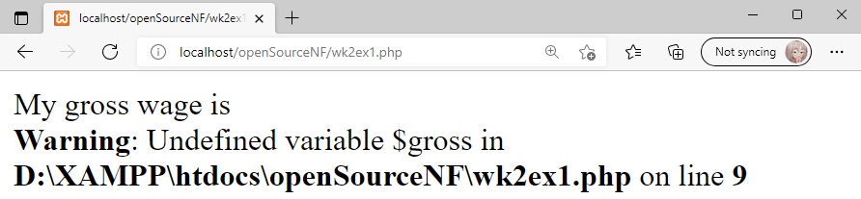

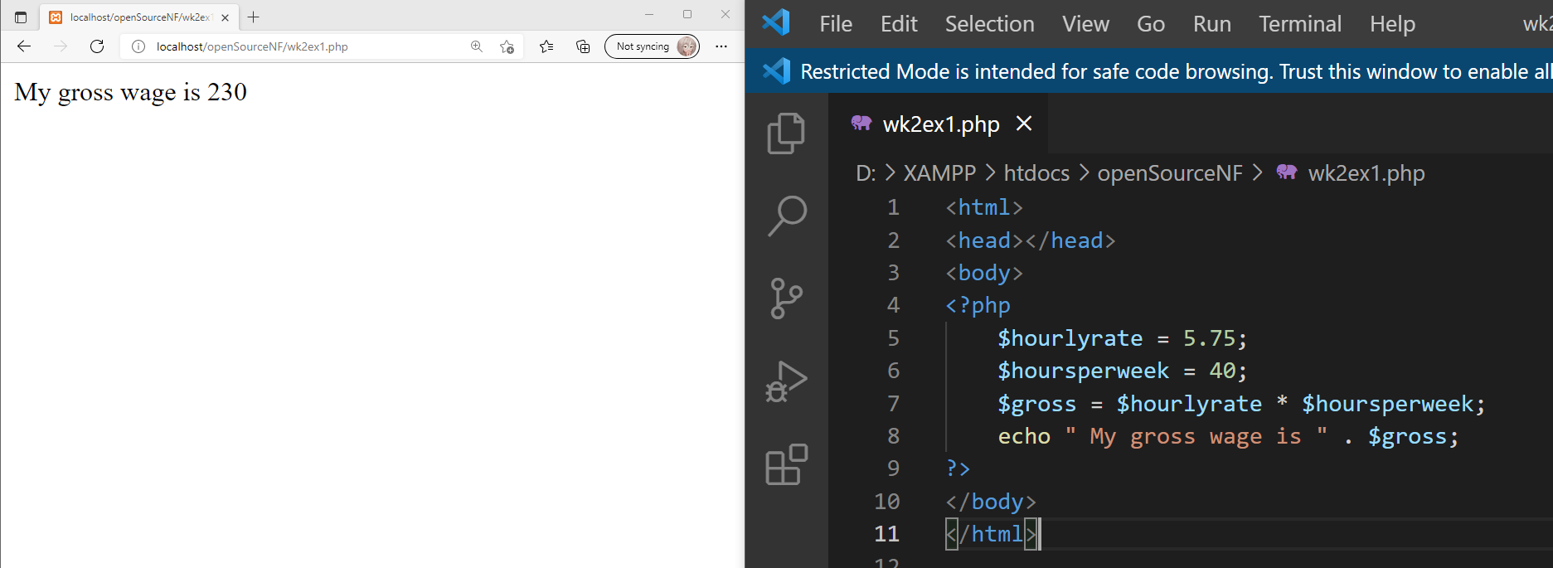

Exercise 2
Save the following script as wk2ex2.php.
Unlike most programming languages php allows different types of data to be assigned to a variable.

<?php
$myage = “None of your business <br/>”;
print($myage);
$myage = 21;
print($myage . “<br/>”)
$myage = 21.75;
print($myage);
?>

The above script also illustrates that it is not necessary to enclose the code within html header and body tags although it is advisable especially if you want to format the output. The print function displays the argument passed to it rather like echo.

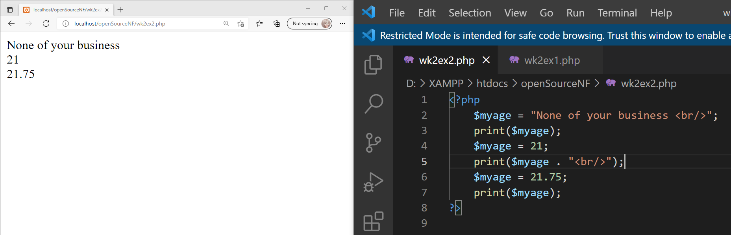

Exercise 3
Save the following script as wk2ex3.php
Constants are created using the define function, they differ from variables in that they are not preceded with a dollar sign and their value can not be changed.
<?php
define(“PASS_GRADE”,40);
echo “You need “ . PASS_GRADE . “ % or more to pass. <br/>”;
$grade = PASS_GRADE + 15;
echo “To achieve a merit you need $grade % or more <br/>”;
$grade = PASS_GRADE + 30
echo “To achieve a distinction you need $grade % or more <br/>”;
?>

While variables can be embedded within the text enclosed in double quotation marks that follow the echo key word, constants can not and must be concatenated to the text using the “.” operator.

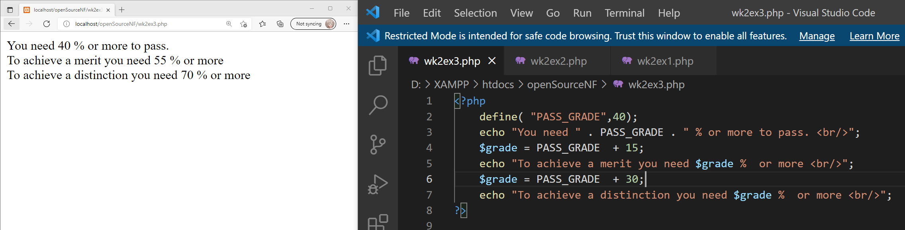

Exercise 4
Save the following script as wk2ex4.php

<! - - Speed camera advise script - ->

<?ph
$points = 13;
// Output appropriate message depending on points awarded.
if ( $points >= 12)
{
echo "Public transport is your best option. <br/>";
}
elseif ($points >= 9)
{
echo “If you get caught say your grandmother was driving. <br/>”;
}
else
{
echo “There is no need to worry about the speed limit.<br/>”;
}
?>

Notice how we have included the html <br/> tag in the output from our script. This script also demonstrates how to include html comments within the < ! – - and - - > tags and the c like double slash for single line comments, placed within the <?php ?> tags.

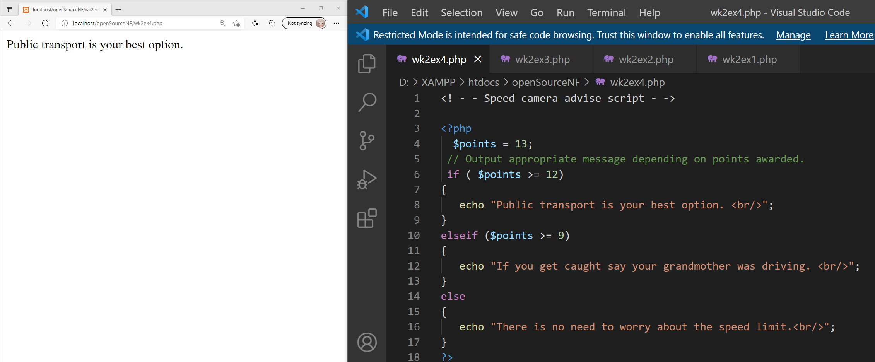

Exercise 5
The next exercise uses the strpos function to determine if the second argument passed to it is contained within the first argument. If it is strpos() returns true otherwise false. Within php != represents not equal to.
Save the following script as wk2ex5.php
<?php
if (strpos($_SERVER["HTTP_USER_AGENT"], "MSIE") != false)
{
echo "You are using Internet Explorer<br/>"
}
else
{
echo “Why are you not using Internet Explorer ?<br/>”;
}
?>

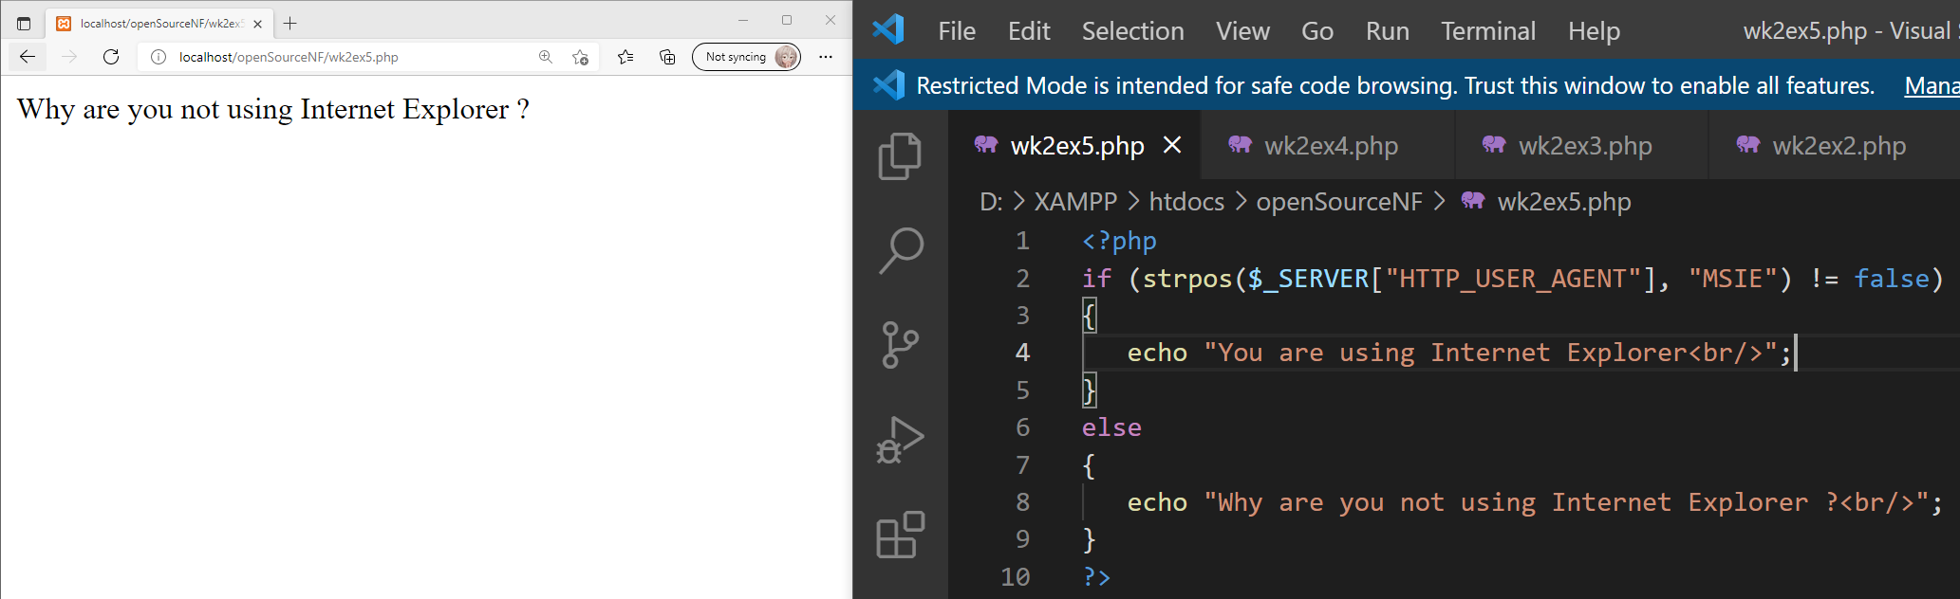

PHP Arrays

Square brackets [ ] at the end of a variable indicate it is one element of an array. Therefore $marks[0] refers to the first element in the $marks array.

$marks[0] = 65;

The statement above assigns a value of 65 to the first element. Unlike other languages PHP does not define the maximum number of elements in the array.

Exercise 6
Create a new file called wk2ex6.php enter the code below and run it.
<?
$marks[0] = 65;
$marks[3] = 55;
$marks[] = 76;

echo " Index 0 = $marks[0] <br/>";
echo " Index 1 = $marks[1] <br/>"
echo " Index 2 = $marks[2] <br/>”;
echo " Index 3 = $marks[3] <br/>";
echo " Index 4 = $marks[4] <br/>”;
echo " Index 5 = $marks[5] <br/>";
?>

If we do not specify an index position i.e. [] where will PHP insert the value?
The PHP will insert the value into the next available index. In the code below, it outputs at index 4 which is the next available index after index 3.

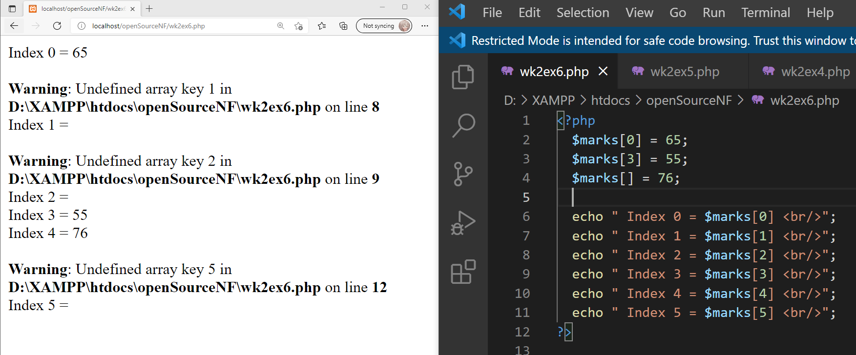

PHP ITERATION

Exercise 7
Enter the code below and save the file as wk2ex7.php

<?
for($count = 0; $count <= 10;$count++);
{
echo “I must behave in class $count <br/>”;
}
?>

The PHP syntax for for loops is similar to C’s
for(Initialization; Condition; Increment)
Before you load the file determine how many lines will be displayed.
It will be displayed 11 times
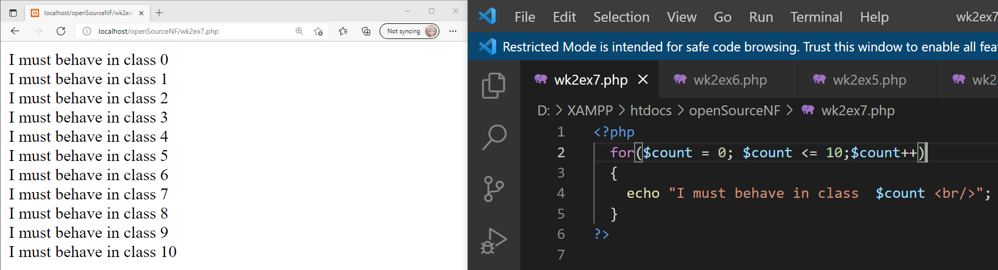

Exercise 8
Loops are commonly used to access the values within arrays, the example below illustrates how we can display the elements of an array.
Save the file below as wk2ex8.php and run it.

HINT: If the code doesn’t seem to run, check the opening PHP tag

<?
$topModules[0] = "Internet Systems Development";
$topModules[1] = "Programming 1";
$topModules[2] = "Programming 2”;
$topModules[3] = "OOAD";
$topModules[4] = "Software Engineering";

for($count = 0,$count < 5;$count++);
{
echo "$count module is $topModules[$count] <br/>";
}
?>

Add two of your favourite modules and amend the loop so that all seven modules are displayed. Load the page to make sure it works.

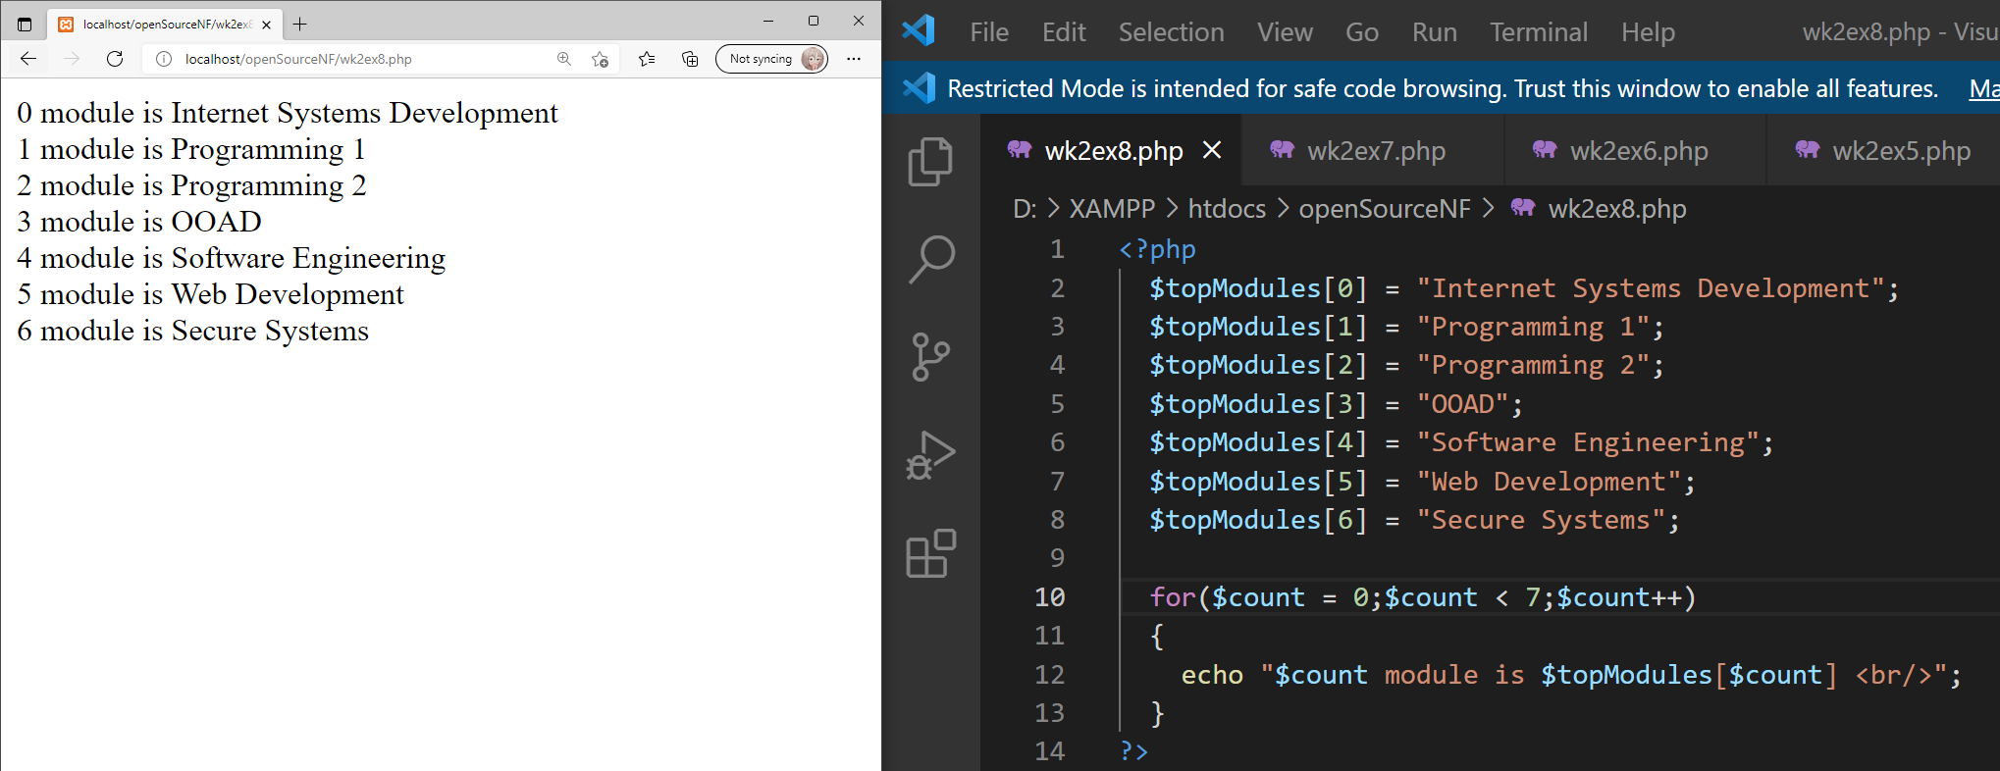

Exercise 9
The previous example would displayed all the elements of the array even if there were no values assigned. If we are only interested in outputting those elements with a value, we can use the foreach() loop.

Enter the code below into a file called wk2ex9.php and research how to write a foreach() loop to output the numeric keys and text values in the $topmodules array.

<?
$topmodules[0] = "Internet Systems Development";
$topmodules[5] = "Programming 1";
$topmodules[10] = "Programming 2";
$topmodules[30] = "OOAD";
$topmodules[40] = "Software Engineering";

// foreach loop here…
{
echo "Index is $index and value is $value <br/>";
}
?>

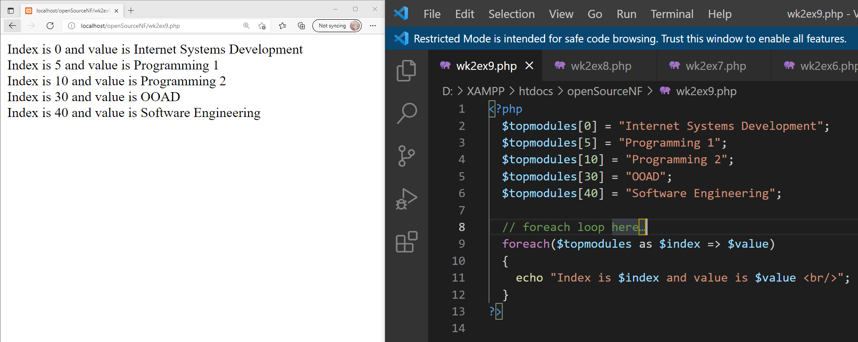

Exercise 10
PHP supports associative arrays, so the index does not have to be an integer.
Copy the code below into a file called wk2ex10.php and complete the foreach() loop syntax, as per the previous task.
<?
$mymarks["year 1"] = 55;
$mymarks["year 2"] = 65;
$mymarks["year 3"] = 75;

// foreach loop here…
{
echo "for $index my grade was $value <br/>";
}
echo "<br/> My best year was Year 3 when I averaged ". $mymarks[“year 3"];
?>

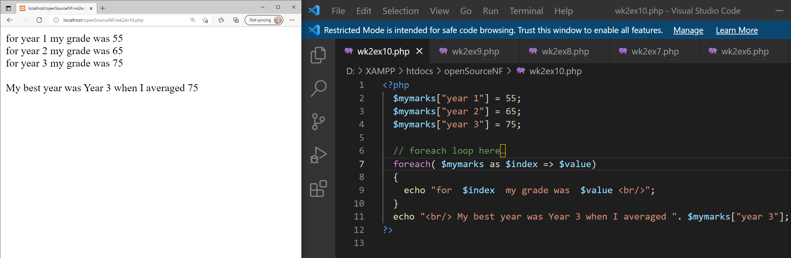

Exercise 11
Create a new PHP file with an array (named $mymarks) holding the marks ( real or imaginary ) for six modules you took last year, use the module code as the array index ( if your not sure what the codes are then make them up ). Then display the marks using a suitable loop. Save the file as wk2ex11.php.

Now insert the following lines in the appropriate places ( not together ) to calculate the average mark.

$total = 0;
$total = $total + $mymarks[$index];
$average = $total / 6;

Create a new line to output your average mark.

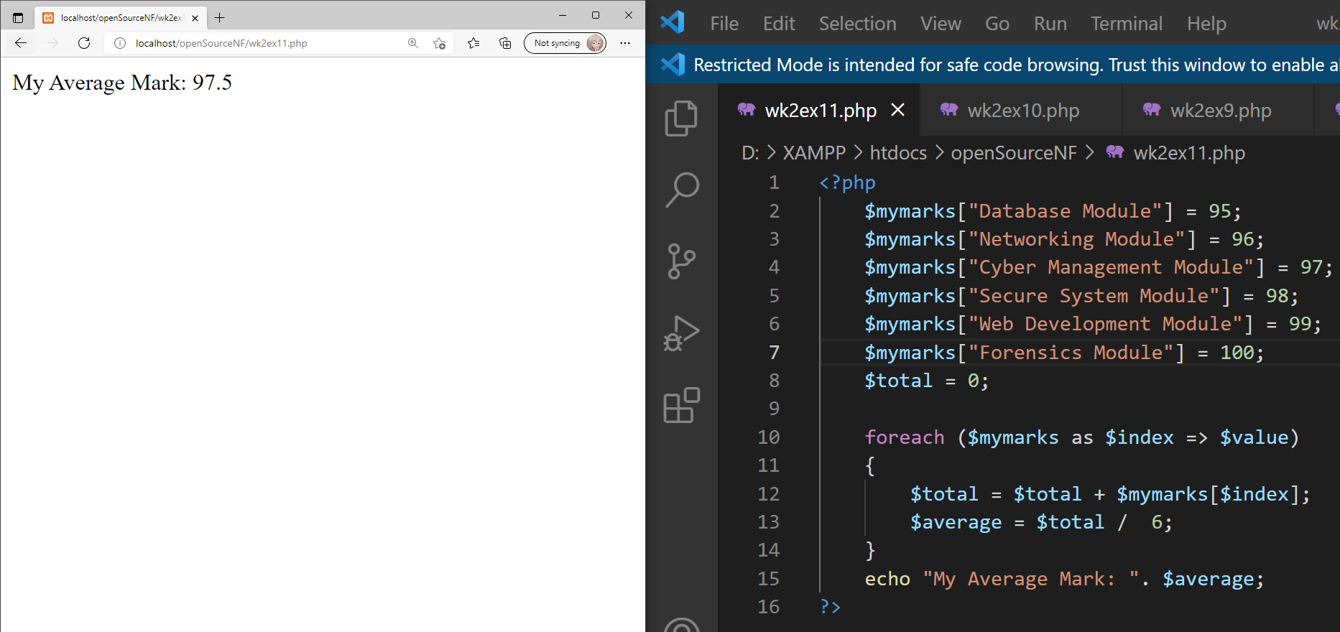

Exercise 12
Sometimes it is appropriate to display the contents of an array within an HTML table. Copy the code below into a file called wk2ex12.php and run it.
<?
$topmodules[0] = "Open Source Systems ";
$topmodules[1] = "Programming 1";
$topmodules[2] = "Programming 2”;
$topmodules[3] = "Web Application Development";
$topmodules[4] = "Software Engineering";

?>
<head>
<title>Data in table</title>
</head>
<body>
<table border=1 align="center">
<tr><th>Index</th><th>Subject</th></tr>
<?
for($count = 0;$count < 5;$count++);
{
echo "<tr><td>$count</td><td>$topmodules[$count]</td></tr>";
}
?>
</table>
</body>
</html>

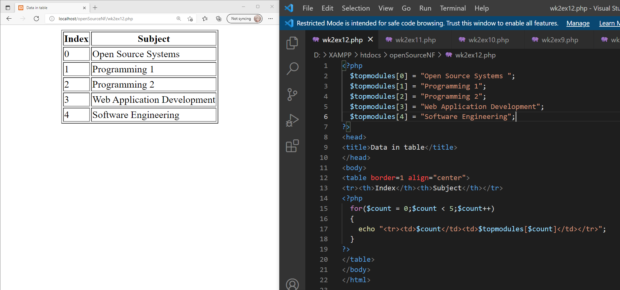

Now revisit wk2ex10.php and display the data in a table.
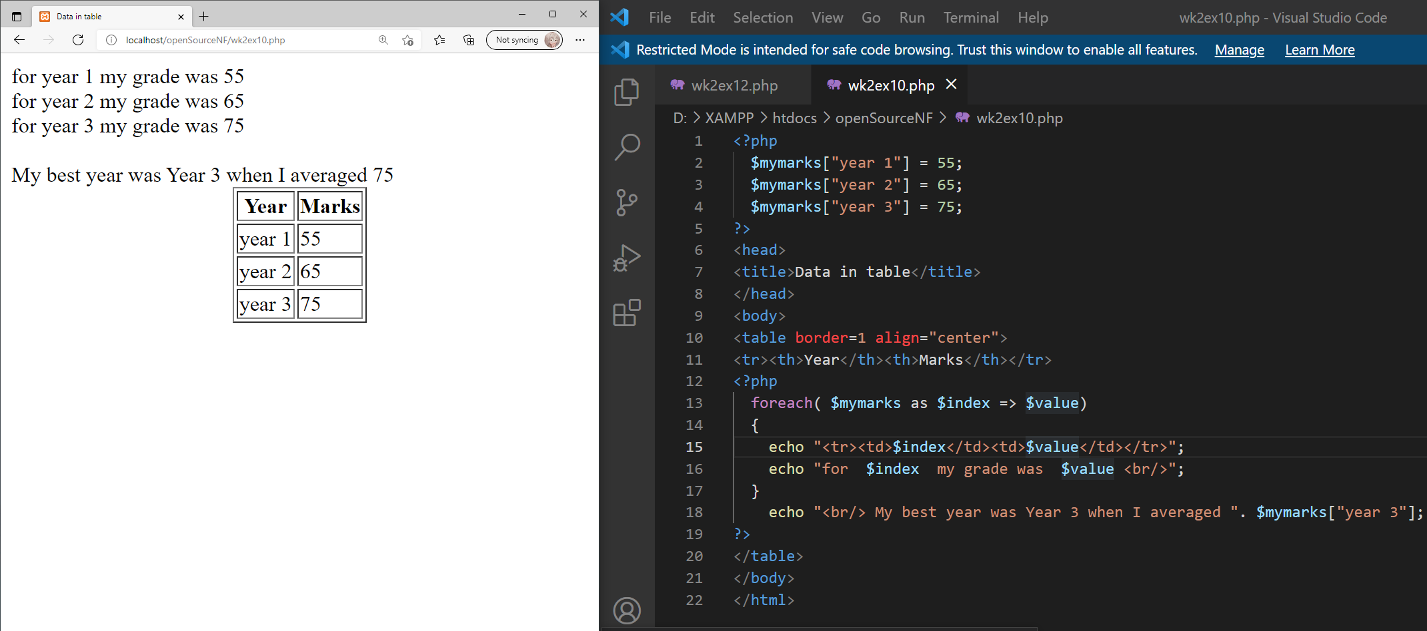

Exercise 13

Complete the second unit “Variables” on the SoloLearn PHP course either via the web or via the mobile: https://www.sololearn.com/Play/PHP

In your final logbook/handout, you will be asked to provide evidence that you completed the whole course in the form of a screenshot of your progress or a screenshot of the certificate of completion.

